Weebly

Weebly is an easy to use, but also quite powerful, web-hosting service that allows the user to "drag-and-drop" while using their website builder. It is free to use though you can pay to upgrade its capabilities (not necessary for this class).
You will be using to create a web site for this class that you will use to hold all your projects done in this class (it will be like an electronic portfolio).
- First you need to create an account for Weebly. Type in your full name, use your school email address and school password when signing in.

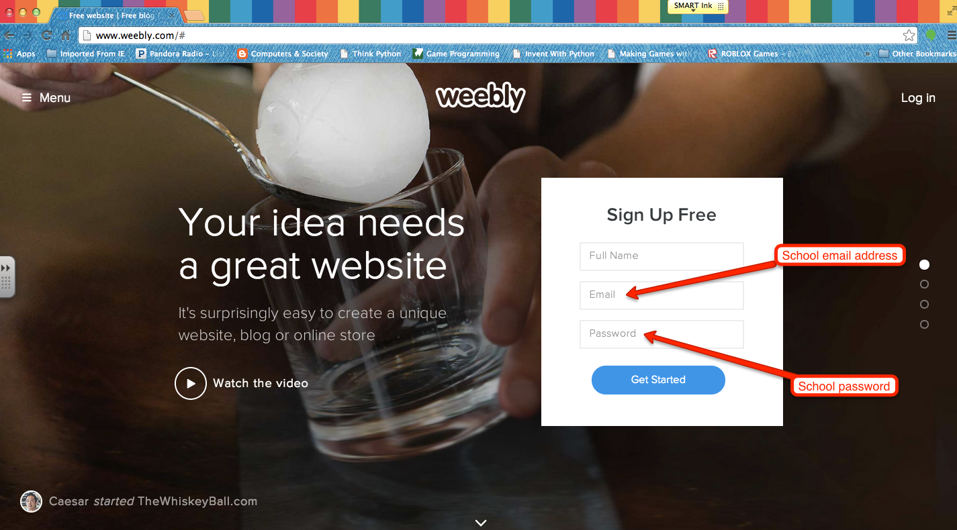

- Select the “Free” plan for our class.

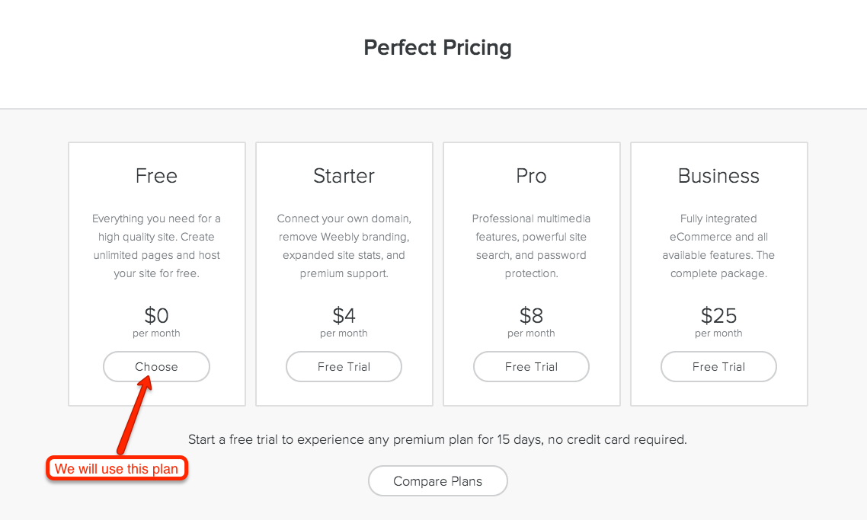

- Choose “Site” as the focus of your Weebly site. We will be adding a ‘Blog’ page to our site later.

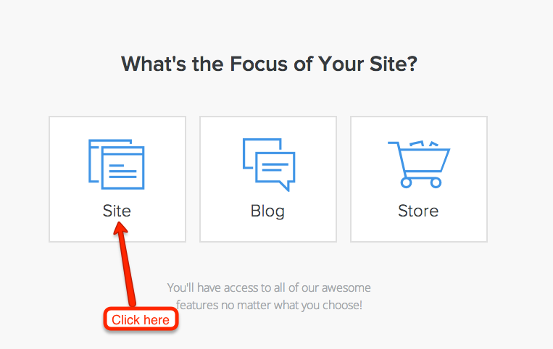

- Choose a Theme for your site. Scroll down for more choices (there is a lot to choose from). It is easy to switch Themes later so do not worry about selecting the ‘perfect’ Theme at this time. When your mouse is over a Theme, a Choose button will appear (as well as Color choices on some Themes), click on that button to get your Theme.

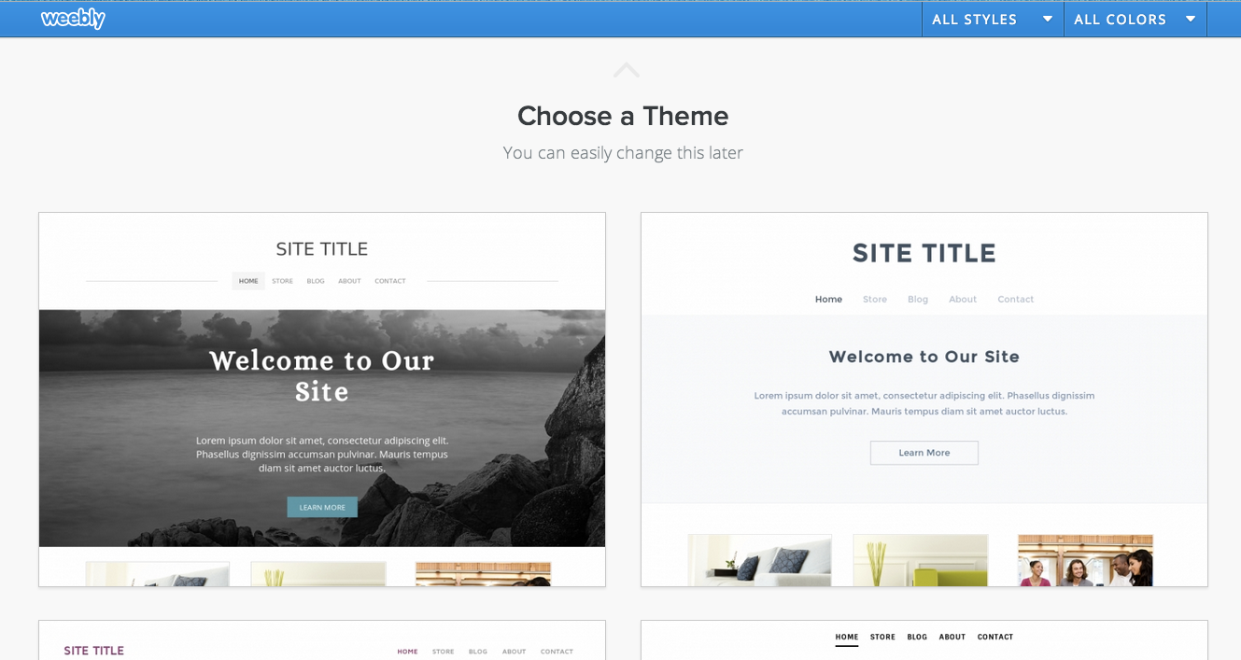

- Select the ‘Subdomain of Weebly’ for your site as this is the Free option. Type in your School username in the blank box. If is available, this will be your web site address (if not available, please contact Mr. Bratina for help). Click on Continue when done typing in your address.

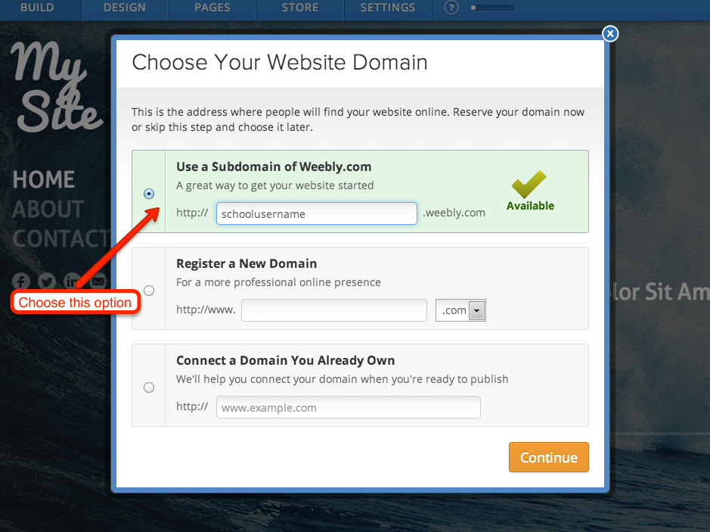

- Click on Build my site to get started.

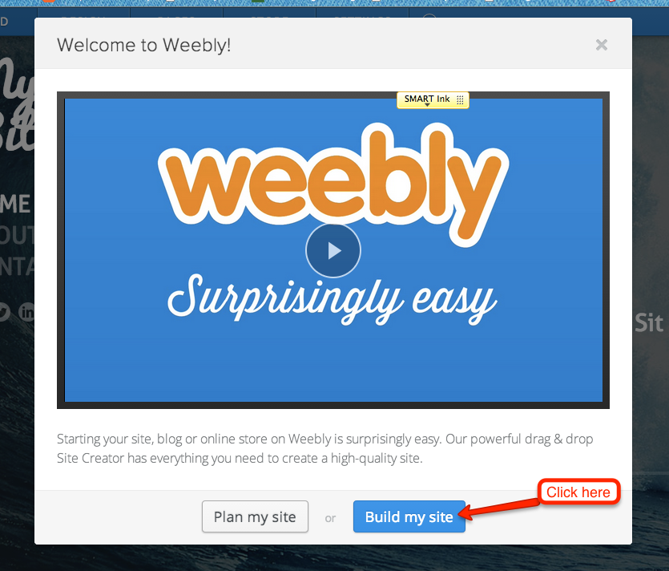

- You are now ready to start creating and customizing your site.

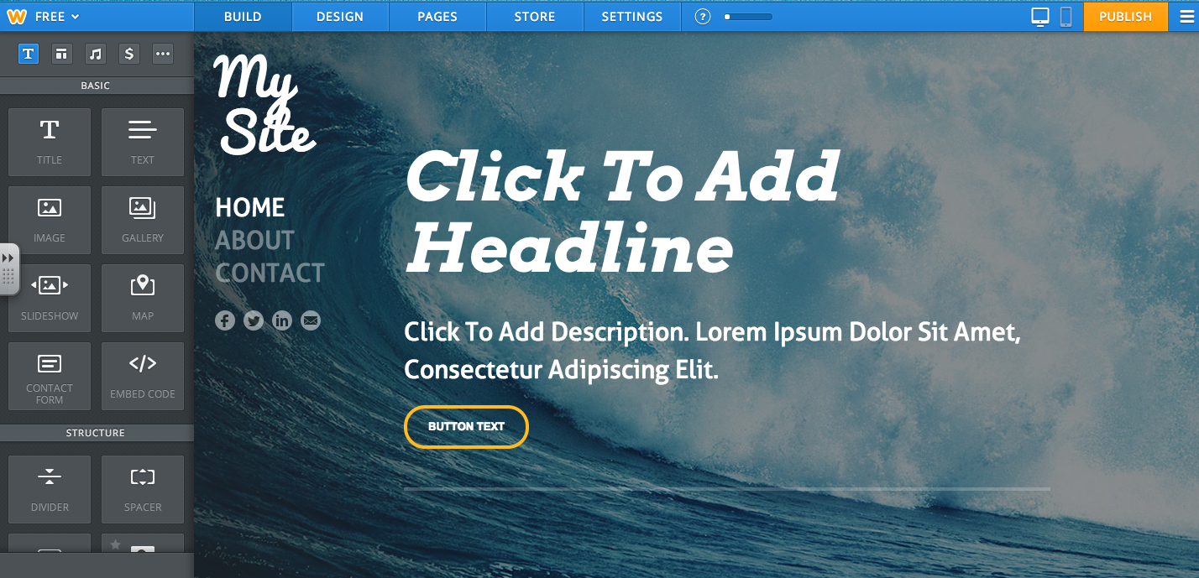

- To see what your site looks like to everyone else, you must click the Publish button first so any changes will be uploaded to your site and then you must open a new TAB and enter your web site address.

